**Predicting Plant Growth Stages of Environmental and Management Data Using Power BI**

**1. Project Title:**

Predicting Plant Growth Stages of Environmental and Management Data Using Power BI

**2. Objective:**

The main objective of this project is to analyze and predict plant growth stages based on environmental (temperature, humidity, sunlight) and management (soil type, fertilizer, water frequency) parameters using Power BI. The insights help in identifying factors that significantly influence plant development and guide better agricultural practices.

**3. Tools & Technologies Used:**

* **Power BI Desktop –** for data visualization and dashboard creation
* **Excel –** for raw data entry and preprocessing
* **DAX (Data Analysis Expressions) –** for calculated fields and KPIs

**4. Dataset Description:**

The dataset contains 193 rows of observations with the following features:

* **Soil_Type**: clay, sandy, loam
* **Sunlight_Hours**: Average sunlight received
* **Water_Frequency**: daily, weekly, bi-weekly
* **Fertilizer_Type**: organic, chemical, none
* **Temperature**: in °C
* **Humidity**: in %
* **Growth_Milestone**: binary (0: Early Stage, 1: Mature Stage)
* **Derived Columns**:

1. Temperature_Range_Description: Cold, Moderate, Warm
2. Humidity_Level_Description: Dry, Moderate, Humid
3. Plant_Growth_Category: Initial Growth, Advanced Growth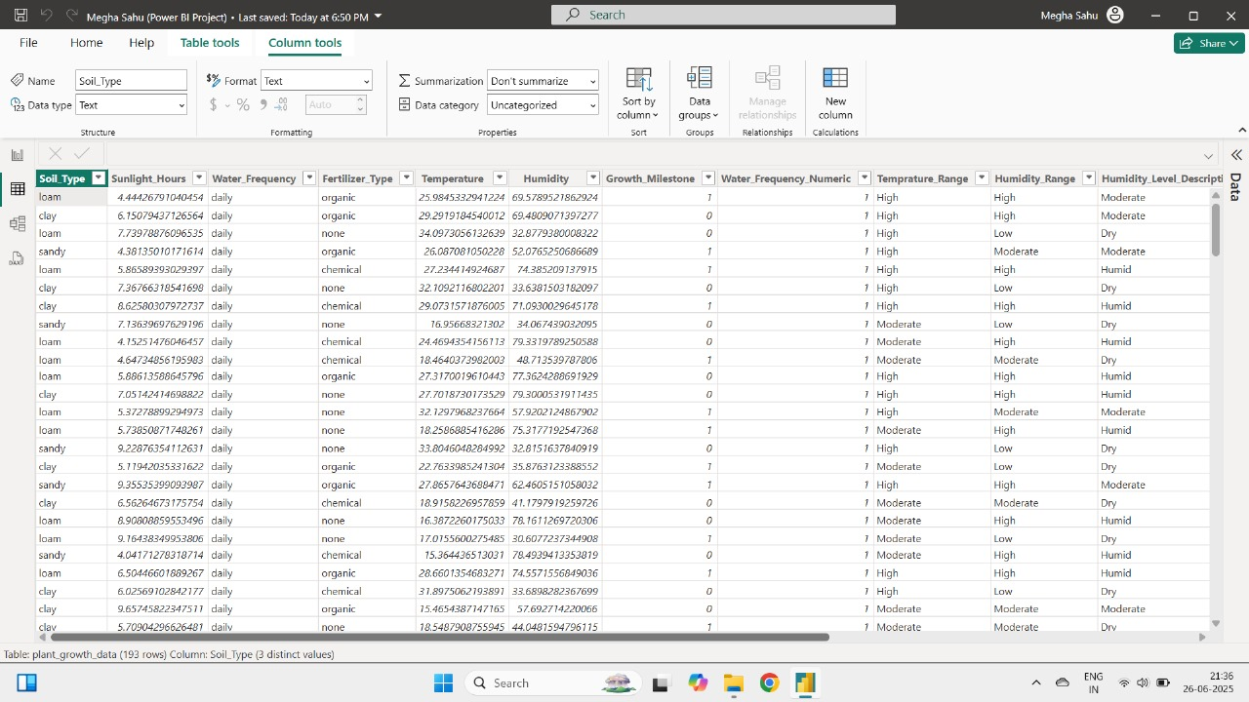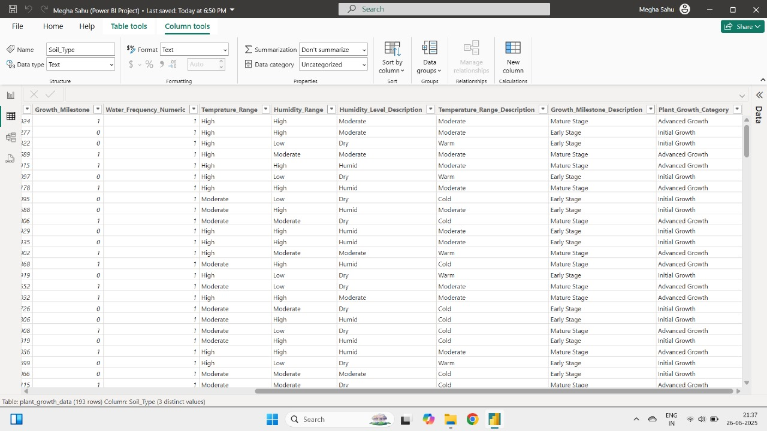

**5. Data Processing in Power BI:**

* Converted and categorized textual and numeric data.
* Created calculated columns for:

1. Temperature_Range_Description
2. Humidity_Level_Description
3. Growth_Milestone_Description
4. Plant_Growth_Category

* Applied slicers, filters, and conditional formatting for dynamic insights.

**6. Key Visualizations:**

**Page 1 – Overview Dashboard:**

* **Growth Milestone by Fertilizer Type (Donut Chart)**: Highlights which fertilizer supports better growth.
* **Average Temperature by Temperature Range:** Shows how temperature range affects average growth.
* **Average Humidity by Humidity Description**: Identifies optimal humidity levels.
* **Growth Milestone Count by Soil Type (Bar Graph):** Determines which soil type supports growth best.
* **Key Influencers Visual**: Displays the main factors influencing temperature and growth using AI-driven insights.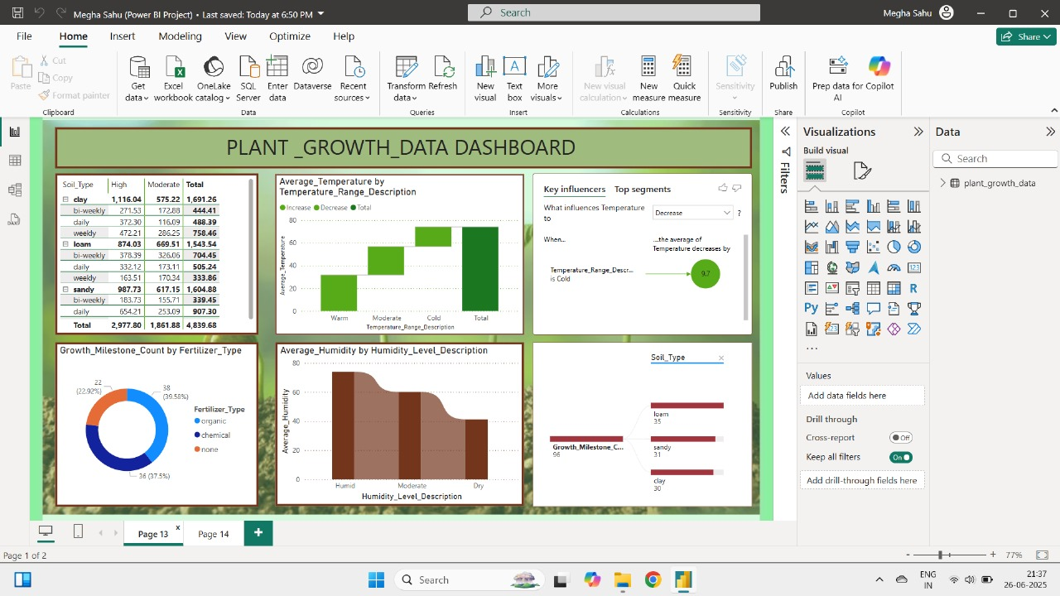

**Page 2 – Detailed Analysis:**

* **Average Sunlight, Humidity, Temperature (KPI Cards)**
* **Average Sunlight Hours by Soil Type (Pie Chart)**
* **Growth Milestone Count by Humidity Level (Line Graph)**
* **Growth Milestone Percentage by Water Frequency (Tree Map)**
* **Report Summary (Textbox):** Auto-generated interpretation of data patterns.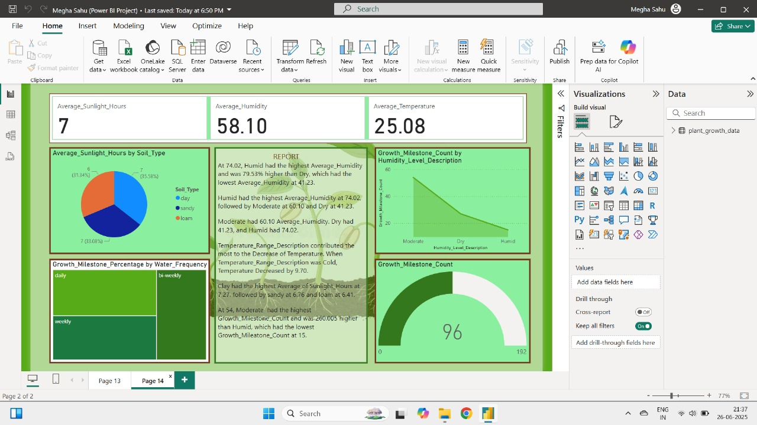

**7. Insights:**

* **Humidity:**

1. Humid conditions recorded the highest average humidity (74.02%) and better plant growth.
2. Dry conditions resulted in the lowest growth stages.

* **Temperature:**

1. Cold temperature contributed the most to decrease in plant temperature average.
2. Moderate and warm temperatures support better growth.

* **Soil Type:**

1. Clay soil had the highest average sunlight hours.
2. Loam showed better balance in humidity and temperature.

* **Water Frequency:**

1. Daily watering shows higher growth milestone achievement than weekly or bi-weekly.

* **Fertilizer:**

1. Chemical and organic fertilizers show better performance compared to none.

**8. Conclusion:**

This Power BI project successfully demonstrated how environmental and agricultural management data can be used to predict and visualize plant growth stages. The dashboard provides farmers and agricultural scientists with a data-driven tool to optimize plant care strategies, boosting yield and sustainability.

**9. Future Scope:**

* Integrate real-time sensor data for dynamic predictions.
* Add machine learning models to enhance predictive capabilities.
* Expand dataset with more crop varieties and seasonal changes.